





**CONTENT**

**Problem Definition**

**Requirement Analysis**

**Flowcharts /Data Flow Diagrams,**

**Design specifications**

**UI**

**Database Design**

**Work Analysis**

#### 

**DEFINITION OF THE PROBLEM**

Education is a fundamental requirement and for To keep parents and guardians informed about their kids,The need for growth is considerably greater. Exam failure students might not disclose their grades to parents as a result of fear, parents or guardians. Teachers are also overburdened with labour, which makes it become It is challenging to recall each child's intellectual development. Additionally, it's important to inform kids about their grad progress and the minimum score needed to pass External Exams. An online tool to keep track of and update all these is a response to these problems. a tracking website application Update all of these is the answer.

**REQUIREMENT ANALYSIS**

The application will be designed with a set of forms/pages with menus representing choice of activities to be performed.

Following are the functional requirements of the Web application:

**Home Page**: It will display an attractive visual and menus for various operations, including basic functionality such as Registration and Login. After users are logged in, they will be able to access userspecific menus. For example, menus displayed to students will be different from those displayed to teachers.

**Register:** It will allow new users to register on the eStudiez Web application. Users can be one of three types: Students, Teachers, or Parent/Guardian. Registration will begin with selection of new user name and password using which in future they will log in to the eStudiez Web application. Registration details can include existing email id, full name, address, age (in case of student), and so on.

Appropriate error-checking must be done on the fields of the form to ensure correct data. For example, email id can be checked to see if it is of appropriate format. (Hint: Use client-side validation).

# 

# Upon successful registration, an email should be sent to the user welcoming the user to the application.

Login: It will allow successfully registered users to get logged in to the eStudiez Web application and access its various features. After a user has logged in, the username should be displayed at the top right corner

**Sign Out:** Using this, logged in users can log out from the Web application.

**Feedback and Contact Us:** These menu options have common functionality for all category of users regardless of whether they are students, teachers, or parents/guardians. Feedback menu option should enable users to provide their feedback about this portal through a feedback form. Contact Us menu option should enable users to contact the creators of the portal. An email id can be displayed here for contact information. Other menus will be different depending upon the type of users:

**For Students:** Marks that they have scored in internal tests conducted by teachers will be displayed in a table. Academic Progress menu option will display the gradual progress in various tests across the year in the form of table data or graphical elements such as progress bars. Study Resources menu option should display a table containing links to external sites, Videos, and additional textbooks. Revision Classes menu option should display information pertaining to extra classes for revision purposes. Date and time of these classes can be displayed here numbers that students can call in case they require general assistance.

# 

In this project, all key data shown on Web pages such as the marks, academic progress, revision class information, and so on will come from relevant database tables and will not be hardcoded.

**For Teachers:** Teachers can update marks that students have scored in internal tests conducted. This can be done through a form. These marks must be updated in the database tables and will reflect on the Student page. Academic Progress menu option will enable teachers to update the gradual progress in various tests across the year. The data for this can be accepted via a form. This data also must be stored in database tables. Add Study Resources menu option should enable teachers to add links to external sites, and additional textbooks. Revision Classes Updation option should accept date and times for extra classes for revision purposes. All of these data will go into database tables

**For Parents/Guardians:** They can view marks and academic progress of their wards. Helplines will display list of phone numbers that parents/guardians can call in case they require general assistance. Marks and other details of wards can also be sent via email to parents when they click an option ‘Send me by Email’.

# 

**Interface Requirements**

**Hardware:**

* Intel Core i5 Processor or higher
* 8 GB RAM or above
* Color SVGA
* 500 GB Hard Disk space
* Mouse
* Keyboard

**Software:**

Technologies to be used:

* **Frontend:** HTML, CSS, Bootstrap, JavaScript, jQuery
* **Backend:** ASP.NET MVC 5
* **Database:** SQL Server 2016

# kids pencil - Online Discount Shop for Electronics, Apparel, Toys, Books, Games, Computers, Shoes, Jewelry, Watches, Baby Products, Sports & Outdoors, Office Products, Bed & Bath, Furniture, Tools, Hardware, Automotive Parts, Accessories

# 

# 

# FLOW CHARTS

**ADMIN:**

# 



**TEACHER:**

# 

# 

# 

# 

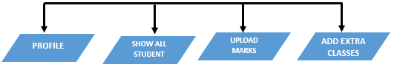

# STUDENT:

# 

# 24,113 School Bag Cartoon Stock Photos and Images - 123RF

**FLOW DATA DIAGRAM**

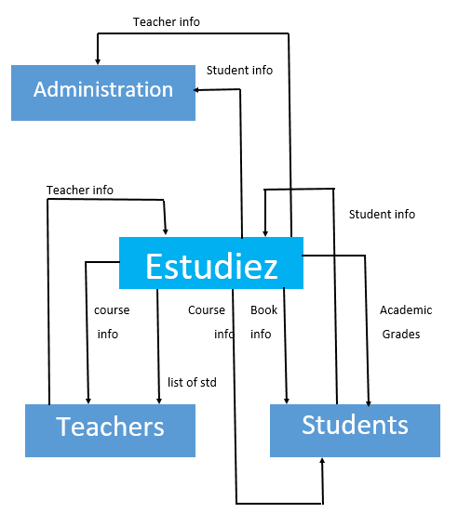



**DESIGN SPECIFICATION**

**Admin:**

After Login Admin Can See all menus available in Estudiez.

Admin can assign the roles to users ( Teachers,Students & Parents )

Admin can edit his and other users profile from profile menu.

Admin can assign roles to the users and view it from StatusUser Account

Admin can add courses from the add courses menu

Admin can add links of books and vidoes from the Add books menu



**Teachers:**

First Teachers has to register him / herself from signup and **after submition successful registration, an email will be sent to the user in spam to welcoming the user to the application** .Like:

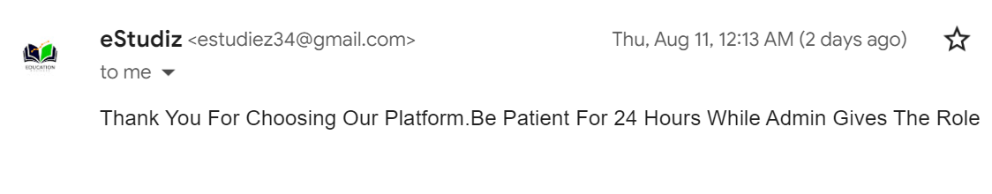

**When admin active the account of teacher an another email will be sent to him/her in spam.**Like:

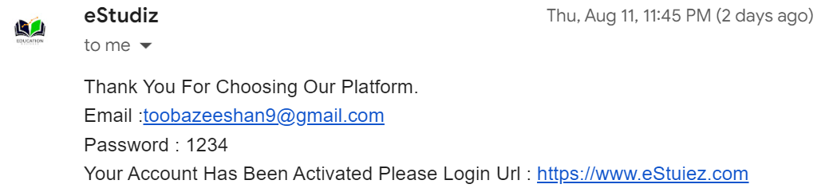

After this teacher can successfully login .

**After login first she has to fill the form from**

**Qualification form menu which required otherwise user can’t see other menus.**

After form submission finally teacher login to the teacher’s Dashboard and a popup will open with helpful instructions for teachers regarding application.





.

Teacher can edit his/her profile from profile menu.

Teacher can view all students which are available in his/her section(i.e Teacher of section A can only see the information of students of section A)

Teacher can upload students marks from upload internal marks menu .

Teacher can arrange extra classes for students From Add Extra classes menu and **email of extra classes with date and time will send to the students in spam** .

**Students:**

First students has to register him / herself from signup and after submition successful registration, **an email will be sent to the user in spam to welcoming the user to the application**

**When admin active the account of Student an another email will be sent to him/her in spam.**

After this Student can successfully login .

**Students can see his internal marks,attain revision classes ,and can check his/her progress from this application.**



**PARENTS:**

First Parents has to register him / herself from signup and after submition successful registration, **an email will be sent to the user in spam to welcoming the user to the application**

**When admin active the account of Parents an another email will be sent to him/her in spam.**

After this Parents can successfully login .

They can view marks and academic progress of their wards by enter their valid id . Marks and other details of wards will sent through email to parents .

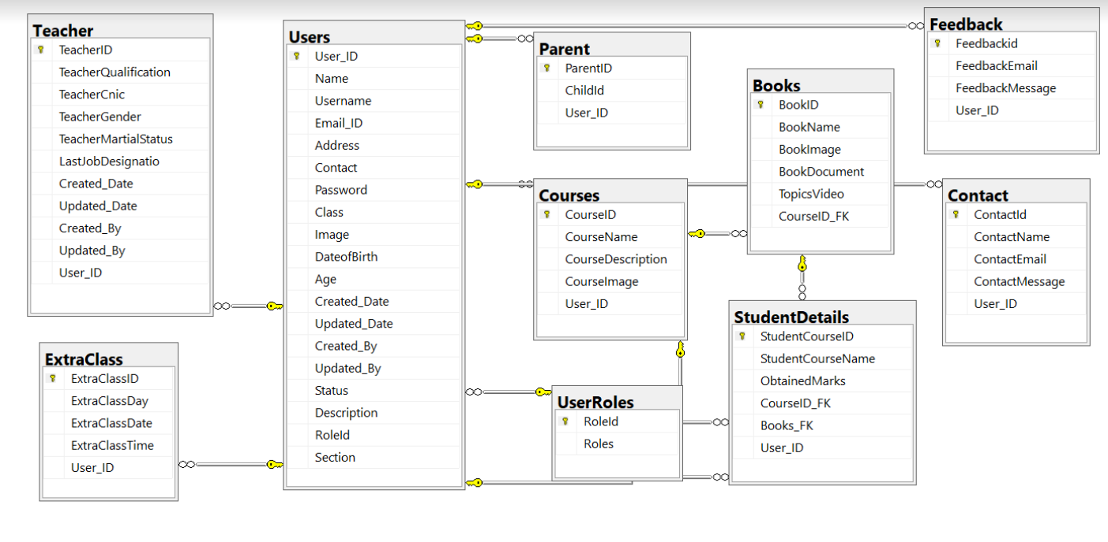****

**DATABASE DESIGN**

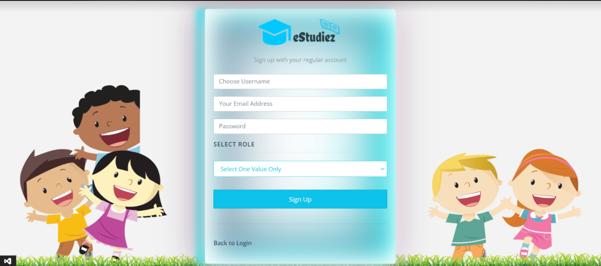****

**SIGNUP**

It will allow new users to register on the eStudiez Web application. Users can be one of three types: Students, Teachers, or Parent/Guardian.

**SIGNIN**

It will allow successfully registered users to get logged in to the eStudiez Web application and access its various features. After a user has logged in, the username should be displayed at the top right corner.

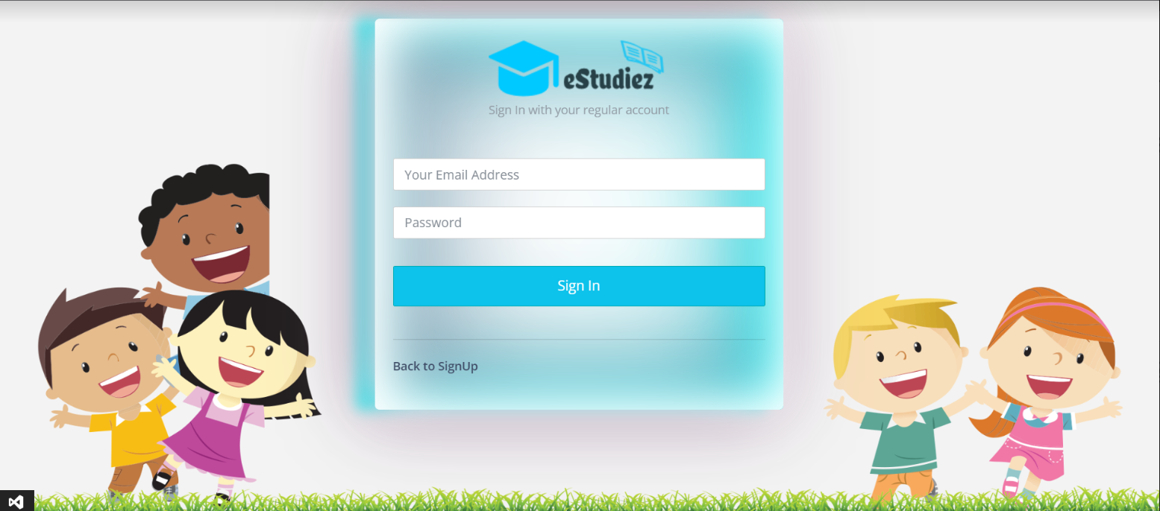



**ADMIN DASHBOARD**

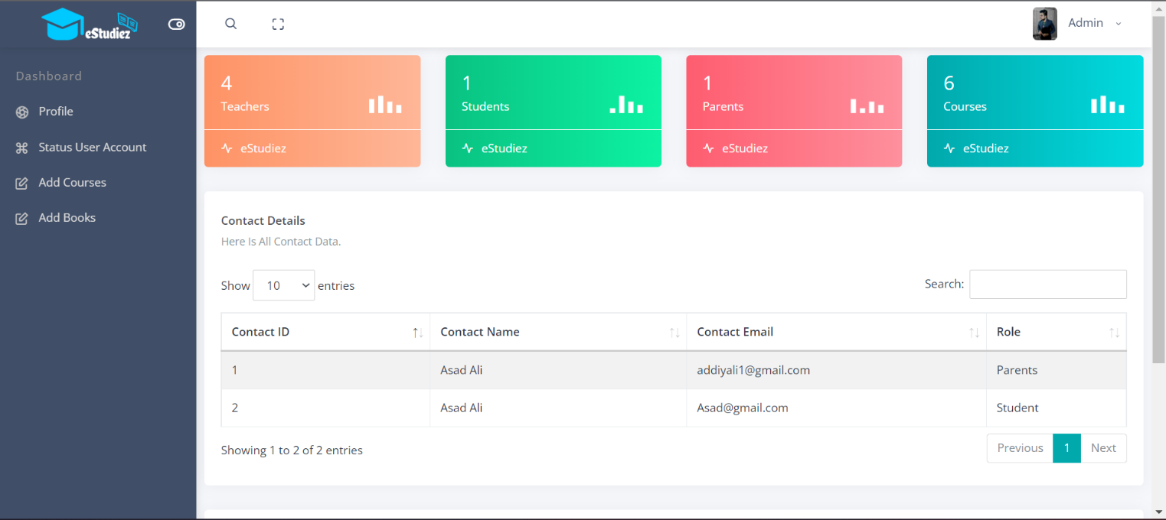

**ADMIN MENU**

**ACTIVE USER STATUS:**

Admin can assign the roles to users ( Teachers,Students & Parents )

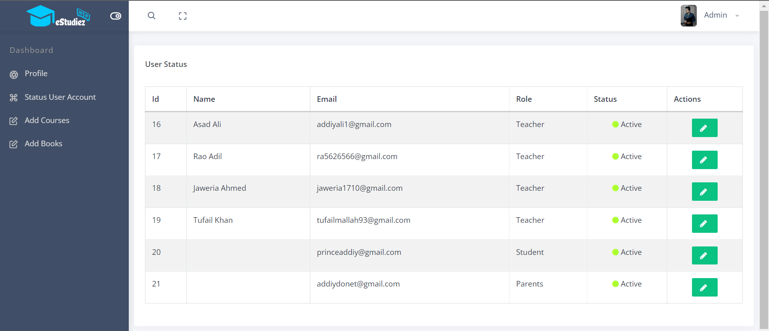



**ADD COURSES:**

Admin can add courses(like CPISM)

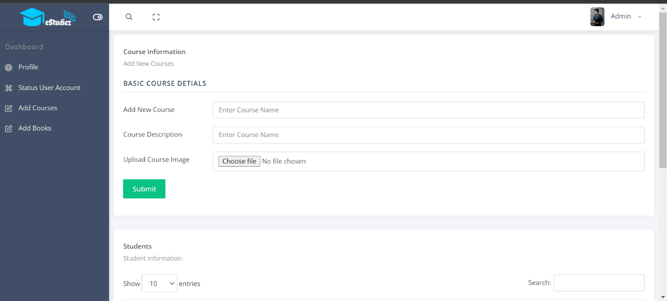



**ADD BOOKS:**

Admin can add links of books and vidoes from the Add books menu

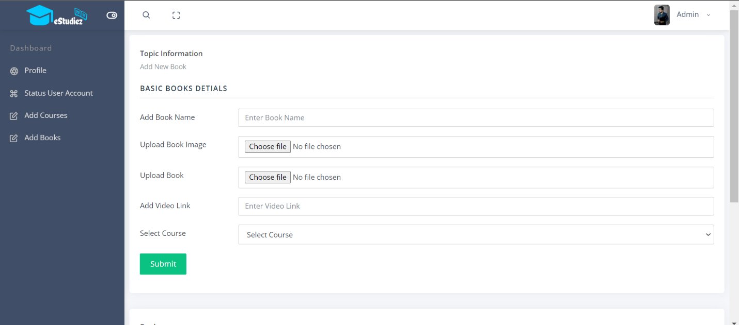



**TEACHER DASHBOARD**

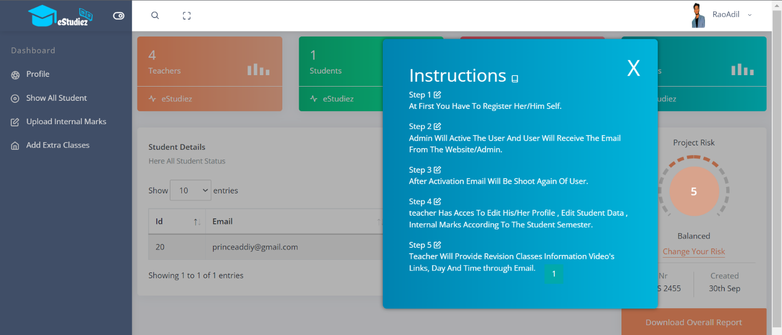

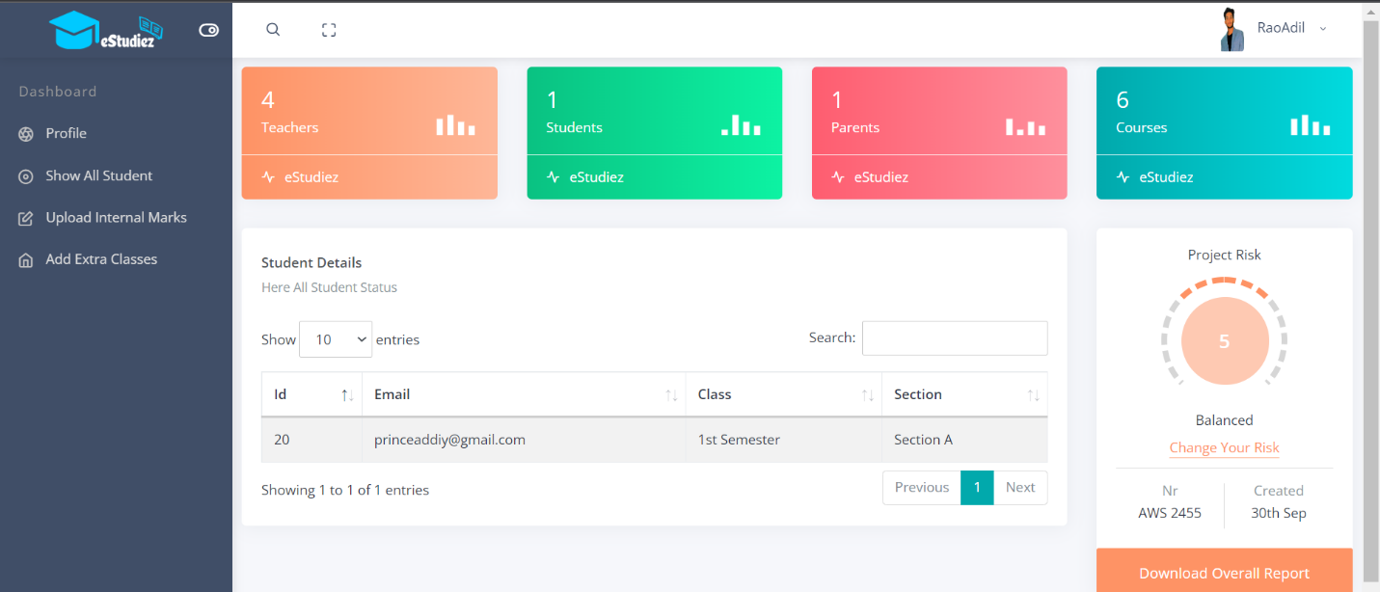

**SHOW ALL STUDENT**

Teacher can view all students which are available in his/her section(i.e Teacher of section A can only see the information of students of section A)

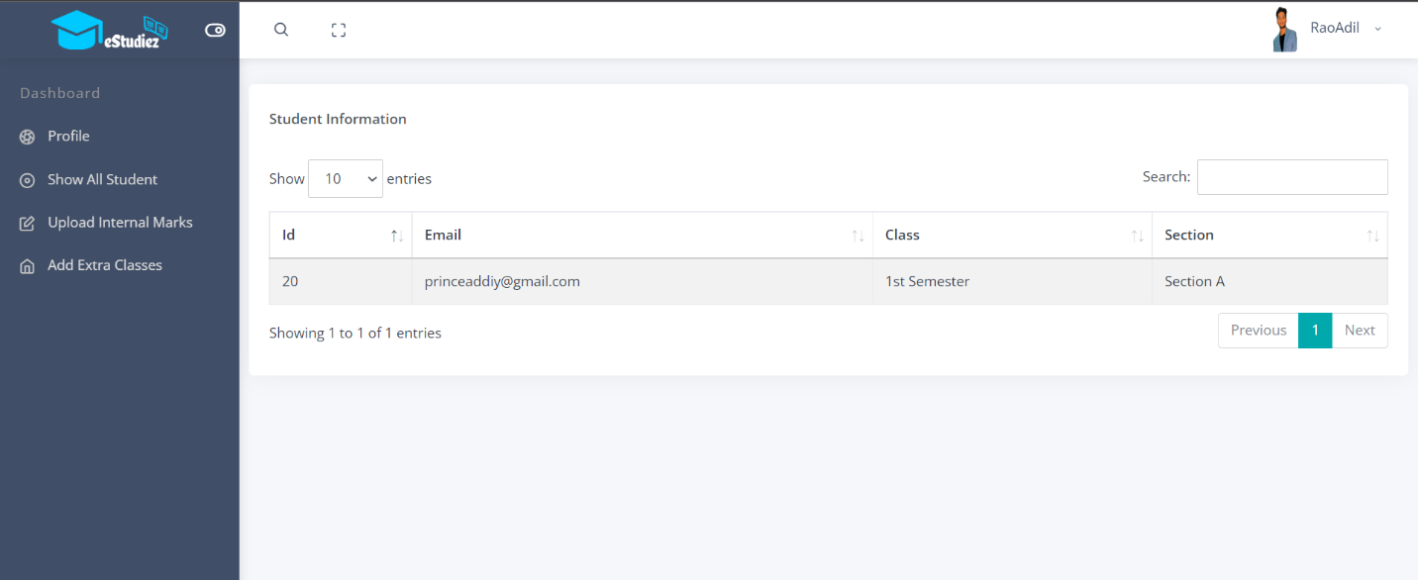

**UPLOAD INTERNAL MARKS**

Teachers can update marks that students have scored in internal tests conducted.

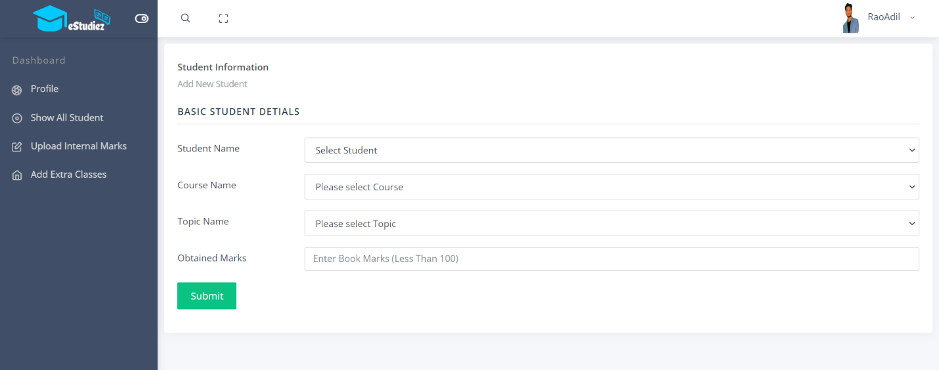

 **ADD EXTRA CLASSES**

Revision Classes Updation option should accept date and times for extra classes for revision purposes.

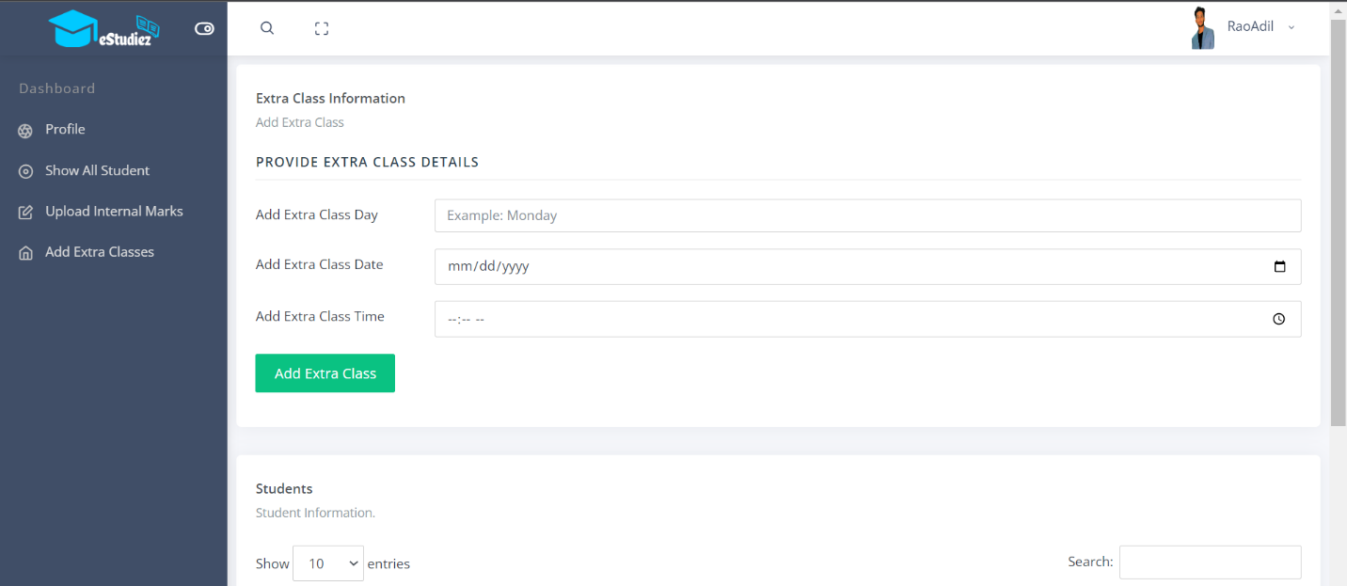



**HOME PAGE**

It will display an attractive visual and menus for various operations, including basic functionality such as Registration and Login.

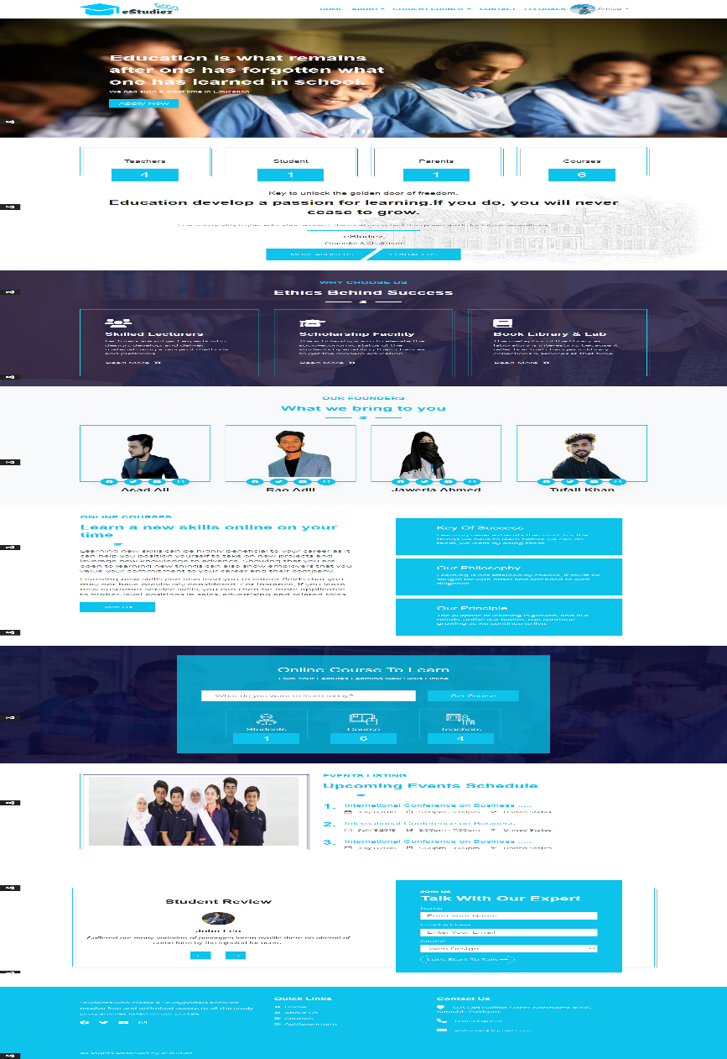

**STUDENT RESULT**

Marks that they have scored in internal tests conducted by teachers will be displayed in a table.





**STUDY RESOURCES MENU**

Study Resources menu option should display a table containing links to external sites, Videos, and additional textbooks





**REVISION CLASSES MENU**

Revision Classes menu option should display information pertaining to extra classes for revision purposes. Date and time of these classes can be displayed here

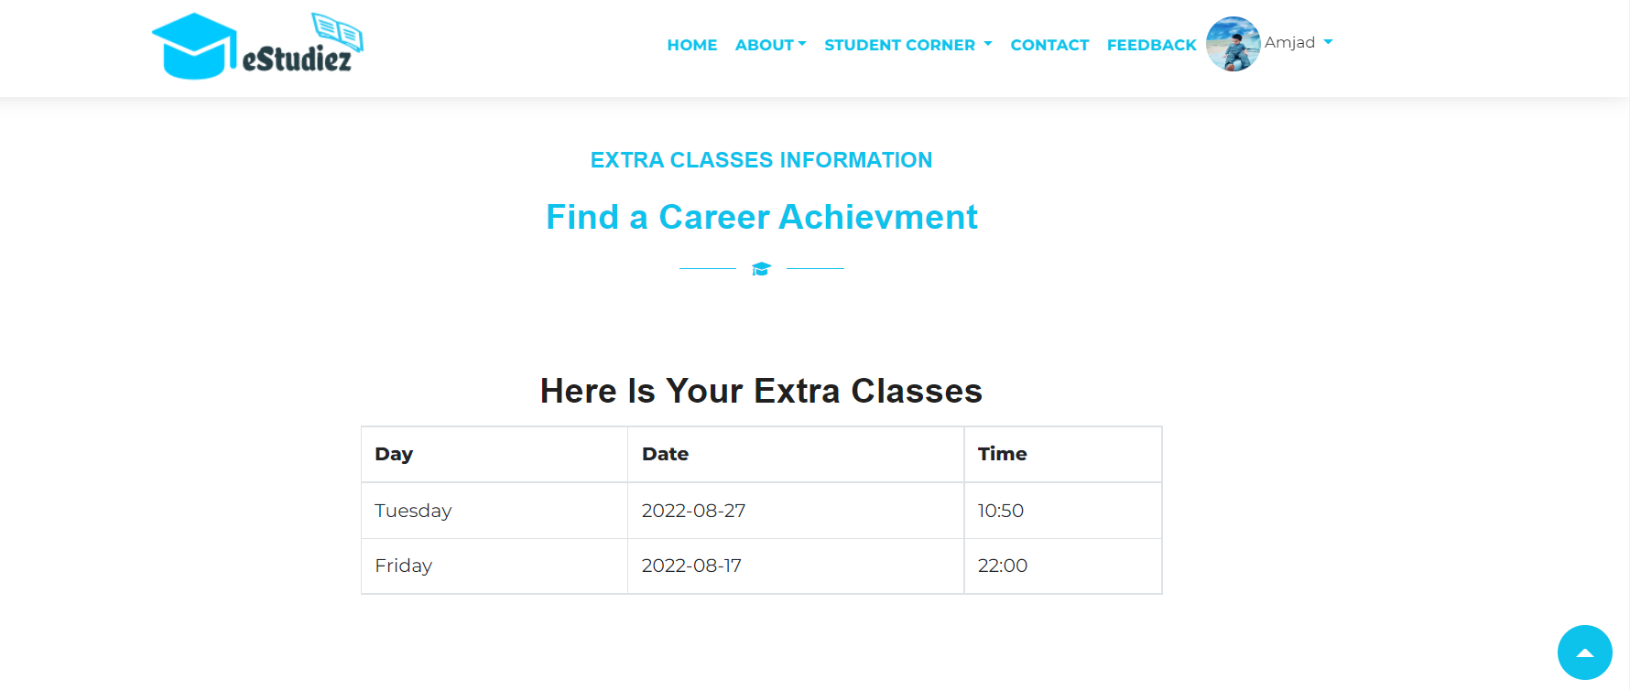



**EMAIL:**

Optionally, there can also be options to receive these information through email.

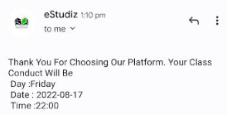



**ACADEMIC PROGRESS MENU FOR PARENTS**

They can view marks and academic progress of their wards.

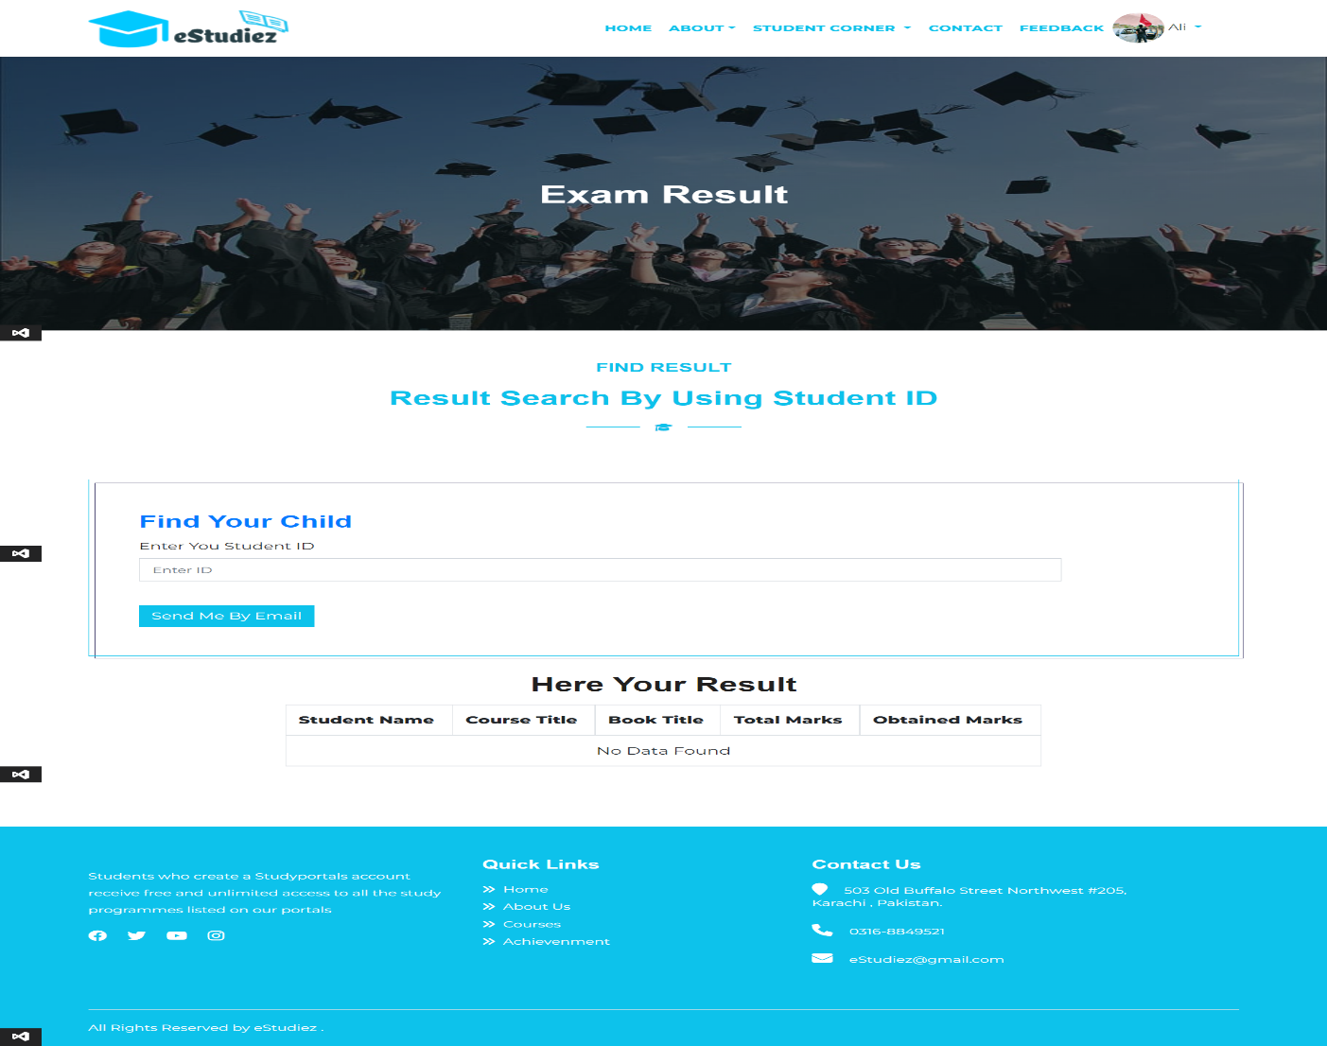

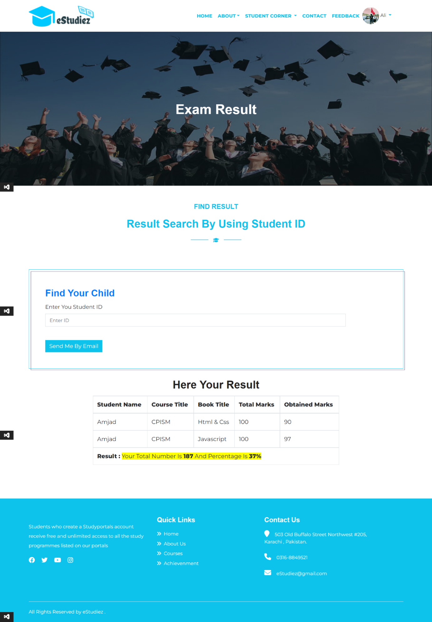****

****DESCRIPTION OF DATABASE

**Users Table Description:**

|  |  |
| --- | --- |
| **Table** | **Data Type** |
| Users_ID | Int (Primary Key) |
| Name | Varchar |
| Username | Varchar |
| Email_ID | Varchar |
| Adress | Varchar |
| Contact | Varchar |
| Password | Varchar |
| Class | Varchar |
| Image | Varchar |
| DateofBirth | Varchar |
| Age | Varchar |
| Created_Date | Varchar |
| Updated_Date | Varchar |
| Status | Varchar |
| Description | Varchar |
| RoleId | Int |
| Section | Varchar |

**User Table:** is the main table, we have a **Primary key**.

This primary key works as a **Foreign Key** in all other tables.

**Users ID:** use for person’s unique identification.

**Email_ID:** use for login / Sign in.

**Password:** use for Security purpose.

**Role ID:** it links all roles to different users like, Admin, Teachers, Parents, Students.

**Teacher Table Description:**

|  |  |
| --- | --- |
| **Table** | **Data Type** |
| TeacherID | Int |
| TeacherQualification | Varchar |
| TeacherCnic | Varchar |
| TeacherGender | Varchar |
| TeacherMartialStatus | Varchar |
| LastjobDesignation | Varchar |
| Created_Date | Varchar |
| Updated_Date | Varchar |
| Created By | Varchar |
| Updated By | Varchar |
| Users_ID | Int (Foreign Key) |

**Teachers Table:** If a person Login his/her self as a teacher so first he/she will be Register.

**Teachers Qualification:** Teacher have to fill Qualification Form for further process.

Teacher receive email from “ESTUDIEZ” after registration.

**Created Date:**  When a user creates his/her account so current date will be created.

**Updated Date:**  When a user does any change his/her profile so updated date will be created.

 **Parent Table Description:**

|  |  |
| --- | --- |
| **Table** | **Data Type** |
| ParentID | Int |
| Childid | Int |
| Users_ID | Int (Foreign Key) |

With the help of this Table Parents have access to see their child’s Academic Record.

**Extra Class Table Description:**

|  |  |
| --- | --- |
| **Table** | **Data Type** |
| ExtraClassID | Int |
| ExtraClassDay | varchar |
| ExtraClassDate | varchar |
| ExtraClassTime | varchar |
| User_ID | Int (Foreign Key) |

With the help of some basic information according to this

Table, Students see their Extra classes schedule after sign in his/her account.

**Courses Table Description:**

|  |  |
| --- | --- |
| **Table** | **Data Type** |
| CourseID | Int |
| CourseName | varchar |
| CourseDescription | varchar |
| CourseImage | varchar |
| User_Id | Int (Foreign Key) |

With the help of this table, User see courses different courses details.

User must have to be register his/her self to see any details.



|  |  |
| --- | --- |
| **Table** | **Data Type** |
| Roleid | Int |
| Roles | varchar |

**User Roles Table Description:**

The Role ID Field designates the field containing the role assigned to the user.

**Books Table Description:**

With the help of this table, Admin can add books name, books image and topic videos. All updates will be updated by course ID.

|  |  |
| --- | --- |
| **Table** | **Data Type** |
| BookID | Int |
| BookName | Varchar |
| BookImage | Varchar |
| BookDocument | Varchar |
| Topicvideo | Varchar |
| CourseID_F | Int |

**Students Details Table Description:**

With the help of Student ID, Students see their marks, Course name and Books name. Show all details of Students .

|  |  |
| --- | --- |
| Table | **Data Type** |
| Student course id | Int |
| Student course name | Varchar |
| Obtained marks | Int |
| Course id_Fk | Int |
| Books FK | Varchar |
| User_id | int |



**Feedback Table Description:**

With the help of this table, Students and parents can share their opinions on the feedback page .

|  |  |
| --- | --- |
| **Table** | **Data Type** |
| Feedbackid | Int |
| FeedbackEmail | Varchar |
| FeedbackMessage | Varchar |
| User_ID | Int(FK) |

**Contact Table Description:**

After login users can contact with ESTUDIEZ Educational System to know any Query.

|  |  |
| --- | --- |
| **Table** | **Data Type** |
| ContactID | Int |
| ContactName | Varchar |
| ContactEmail | Varchar |
| ContactMessage | Varchar |
| User_ID | Int(KF) |



**WORK ANALYSIS**

|  |  |  |
| --- | --- | --- |
| S.NO | TASK DESCRIPTION | ASSIGN TO |
| 1 | Database Design | Aymen Waheed |
| 2 | Backend Design | Adil Ali,  Ansa Shaheen,  Tooba Zeeshan |
| 3 | Front end Design | M Tufail |
| 4 | Testing | Adil Ali |



Thank You